Azamat Salamatov

Professor Mustafa Duran

COMP 1314

December 5, 2022

# Final Project

## 5 Topics I liked the most during the class

### =RAND(X,Y) in MS Word

=rand(x,y) function is used in Microsoft Word to insert a random text. The first number indicates the number of paragraphs and the second indicates the number of lines in each paragraph (Microsoft, PMT function - Microsoft Support).  
By writing =RAND(5,5) and pressing enter key, I get this:

Ex:

Video provides a powerful way to help you prove your point. When you click Online Video, you can paste in the embed code for the video you want to add. You can also type a keyword to search online for the video that best fits your document. To make your document look professionally produced, Word provides header, footer, cover page, and text box designs that complement each other. For example, you can add a matching cover page, header, and sidebar.

Click Insert and then choose the elements you want from the different galleries. Themes and styles also help keep your document coordinated. When you click Design and choose a new Theme, the pictures, charts, and SmartArt graphics change to match your new theme. When you apply styles, your headings change to match the new theme. Save time in Word with new buttons that show up where you need them.

To change the way a picture fits in your document, click it and a button for layout options appears next to it. When you work on a table, click where you want to add a row or a column, and then click the plus sign. Reading is easier, too, in the new Reading view. You can collapse parts of the document and focus on the text you want. If you need to stop reading before you reach the end, Word remembers where you left off - even on another device.

Video provides a powerful way to help you prove your point. When you click Online Video, you can paste in the embed code for the video you want to add. You can also type a keyword to search online for the video that best fits your document. To make your document look professionally produced, Word provides header, footer, cover page, and text box designs that complement each other. For example, you can add a matching cover page, header, and sidebar.

Click Insert and then choose the elements you want from the different galleries. Themes and styles also help keep your document coordinated. When you click Design and choose a new Theme, the pictures, charts, and SmartArt graphics change to match your new theme. When you apply styles, your headings change to match the new theme. Save time in Word with new buttons that show up where you need them.

Figure

### FIND AND REPLACE TEXT IN MS WORD

Find and Replace function in MS Word are located in the rightmost corner of the Home Tab.

“Find” is used for searching and finding the requested word, number, character, etc (Microsoft, Find Function - Microsoft Support).

Ex:

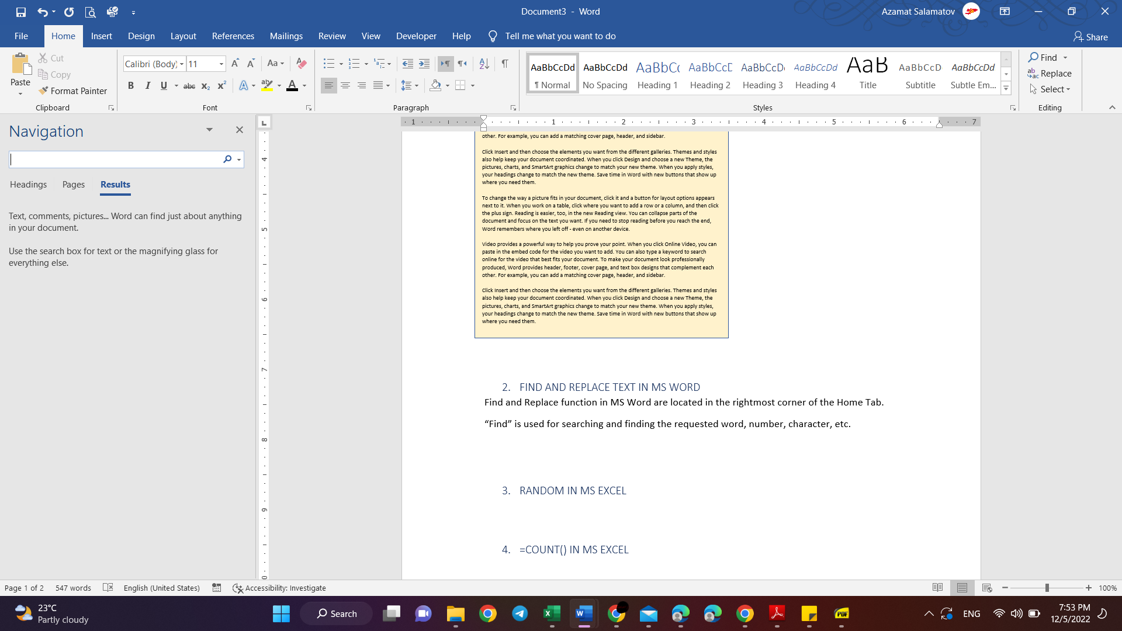

Figure

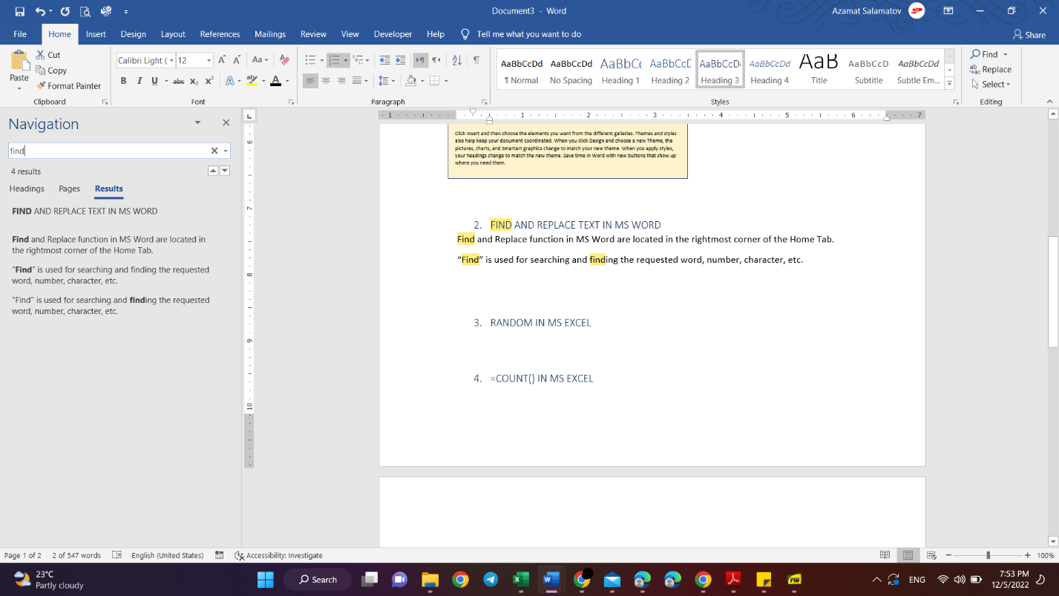

Figure

### =RAND() IN MS EXCEL

=rand() is used in Microsoft Excel for getting random number between 0 and 1. To run it you need to write =rand() (Microsoft, PMT function - Microsoft Support)

Ex:

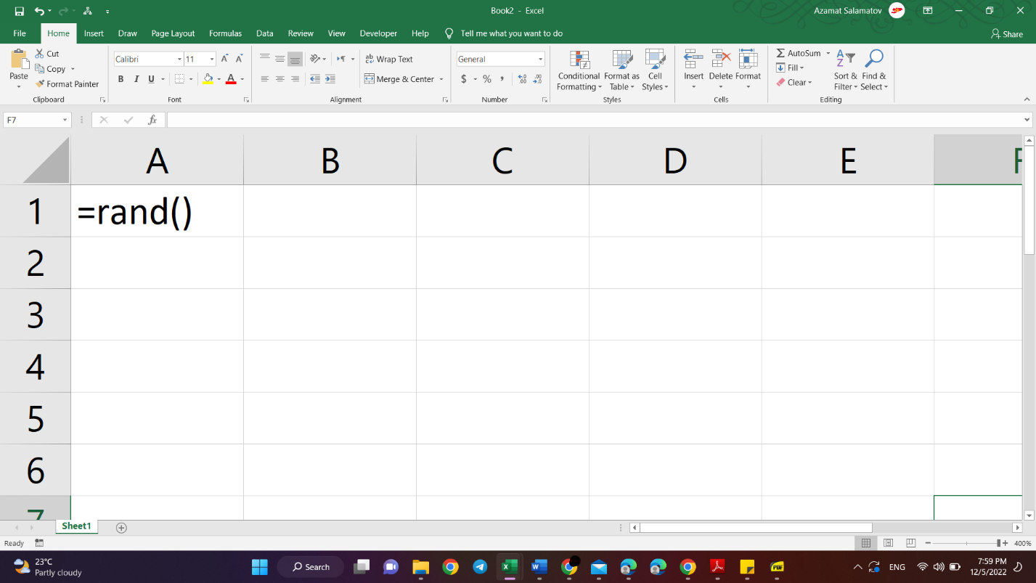

Figure

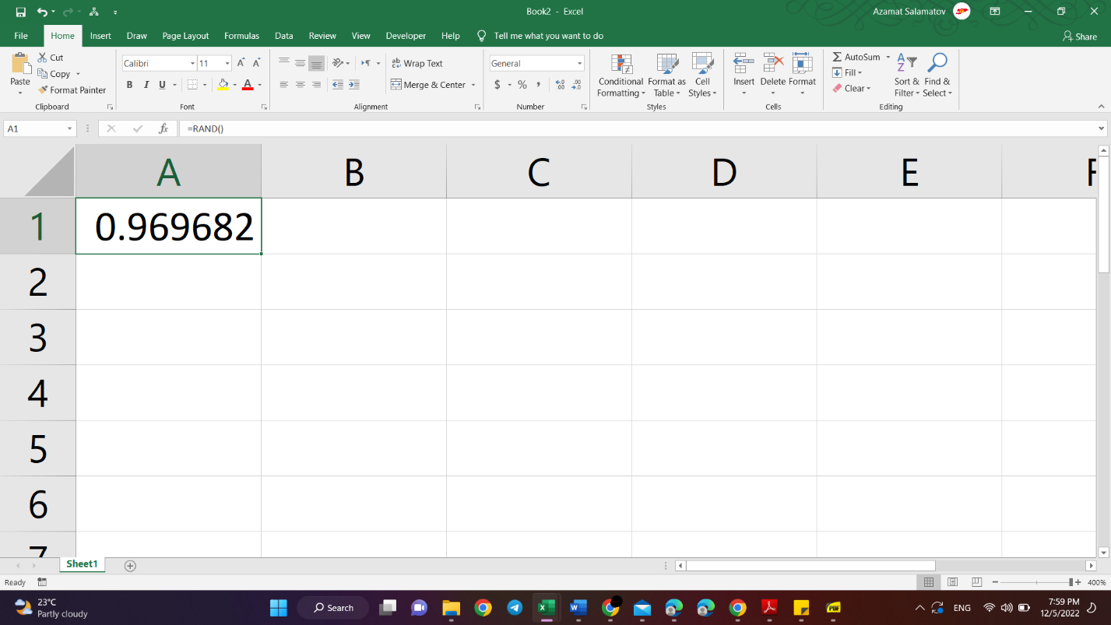

Figure

### =COUNT() IN MS EXCEL

=count() is used in MS excel to count the number of numbers in the given range of cell. It will not count the empty cell, strings, characters, etc (Microsoft, Count function - Microsoft Support).

Ex:

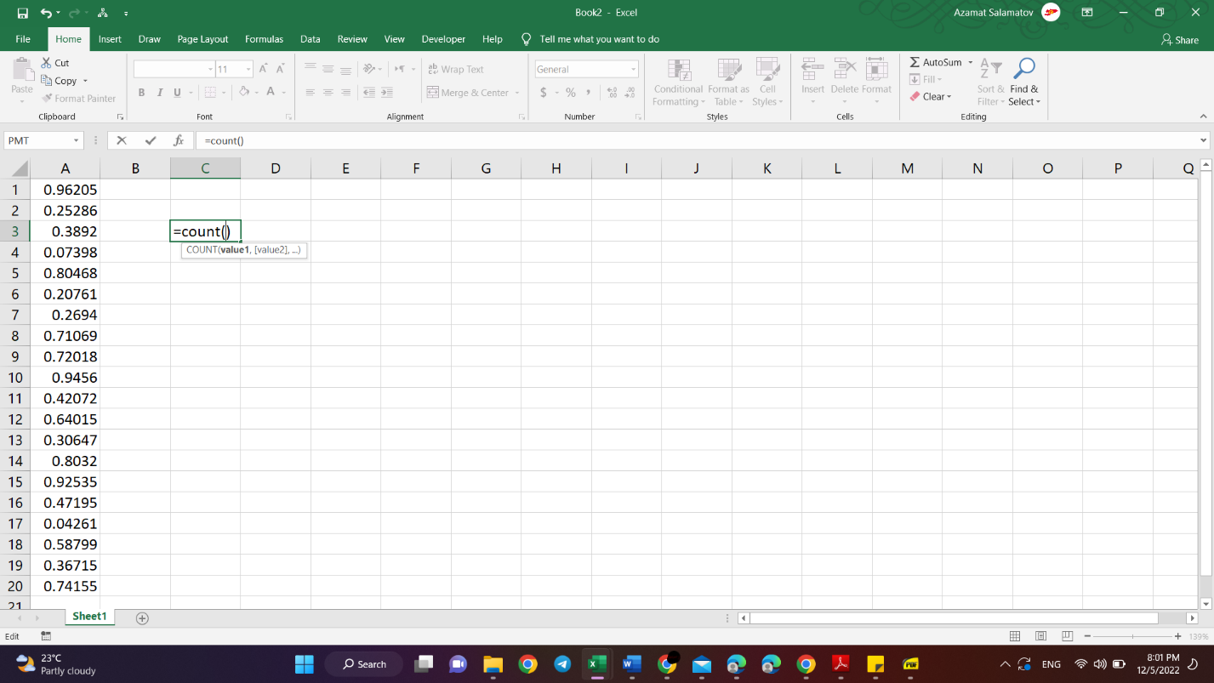

Figure

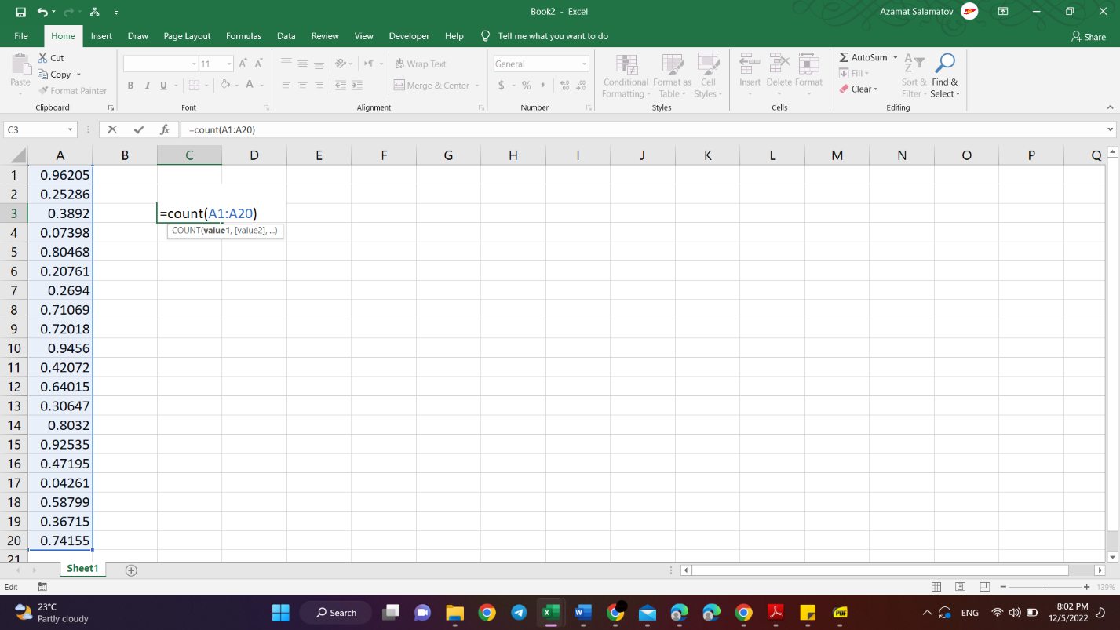

Figure

### NAMING A RANGE OF CELLS IN MS EXCEL

In MS excel, it is possible to create a name for a range of cell, a cell, or a table. Instead of using just A1:G10, you can use the name given to this range of cells (Microsoft, Naming a Range - Microsoft Support).

Ex:

1: first I select the range:

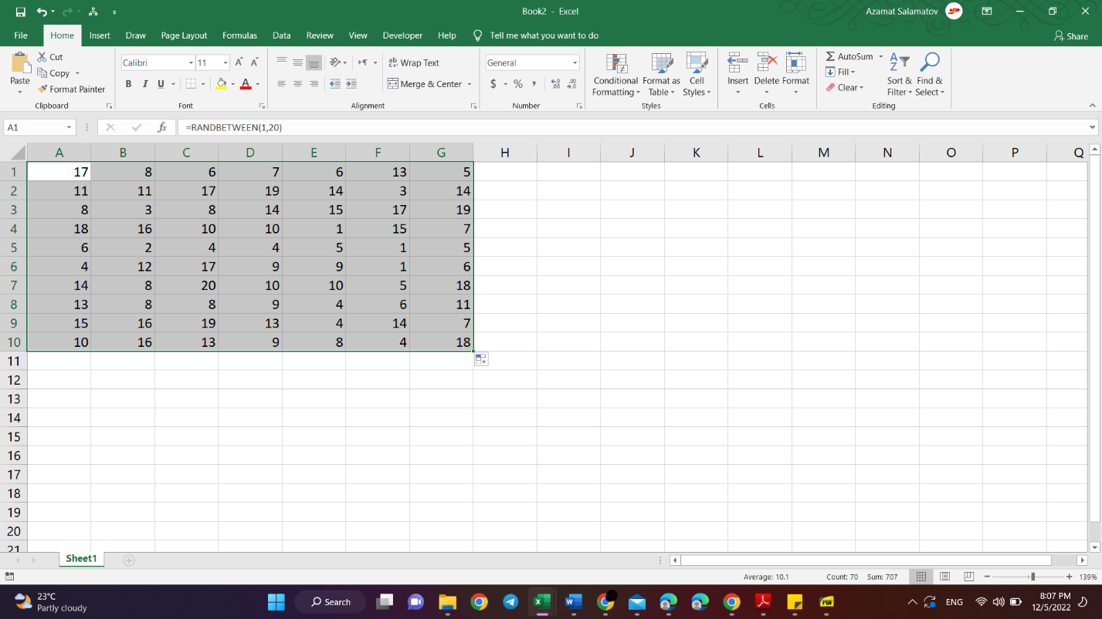

Figure

2: second, I rename the range

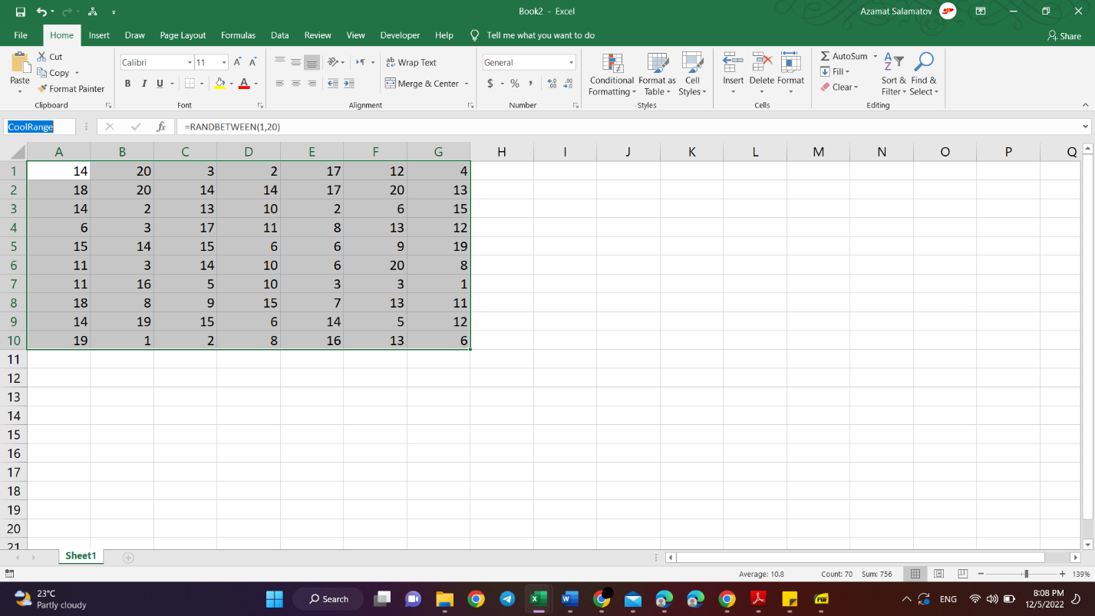

Figure

Now, the range A1:G10 is called “CoolRange”,

In the naming, we can not use spaces, that is why I used the camel style of naming

## 2 Topics I did not know before the class

### Table of contents IN MS WORD

In the reference Tab, we can insert the table of contents to our document.

Ex:

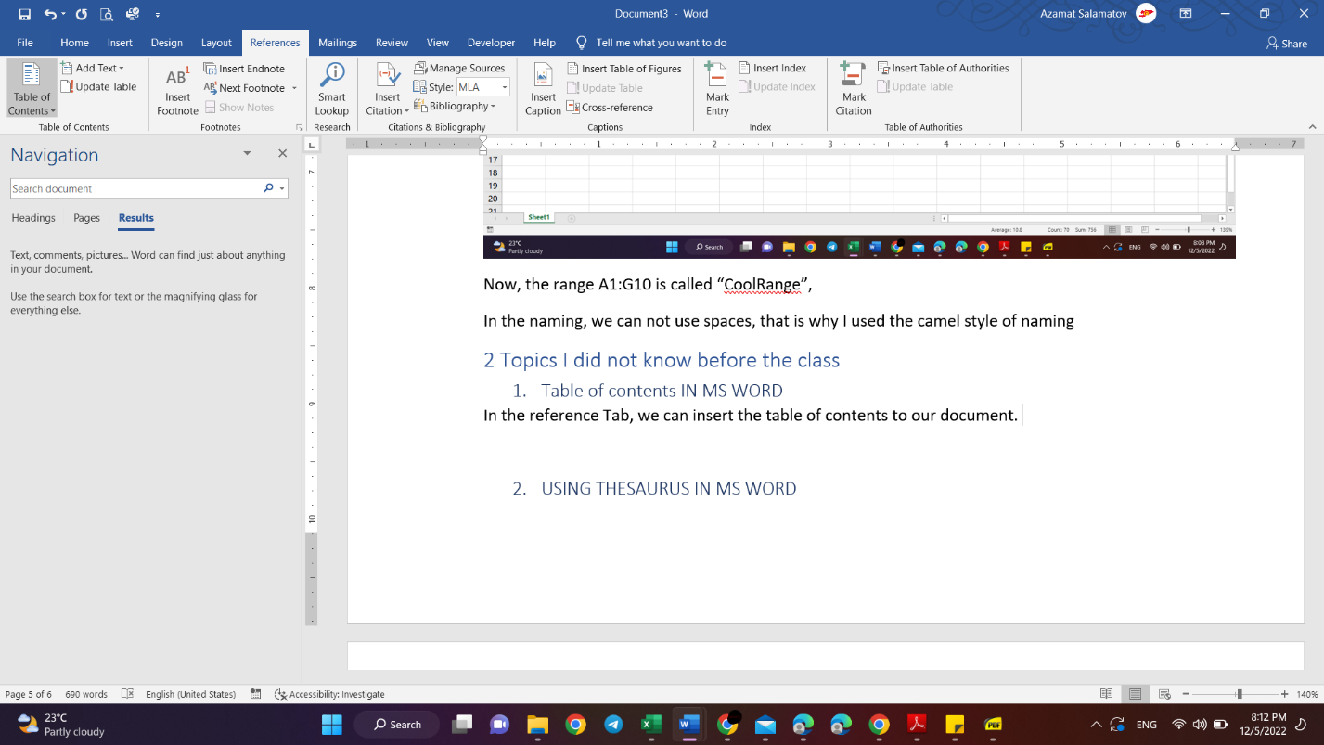

Figure

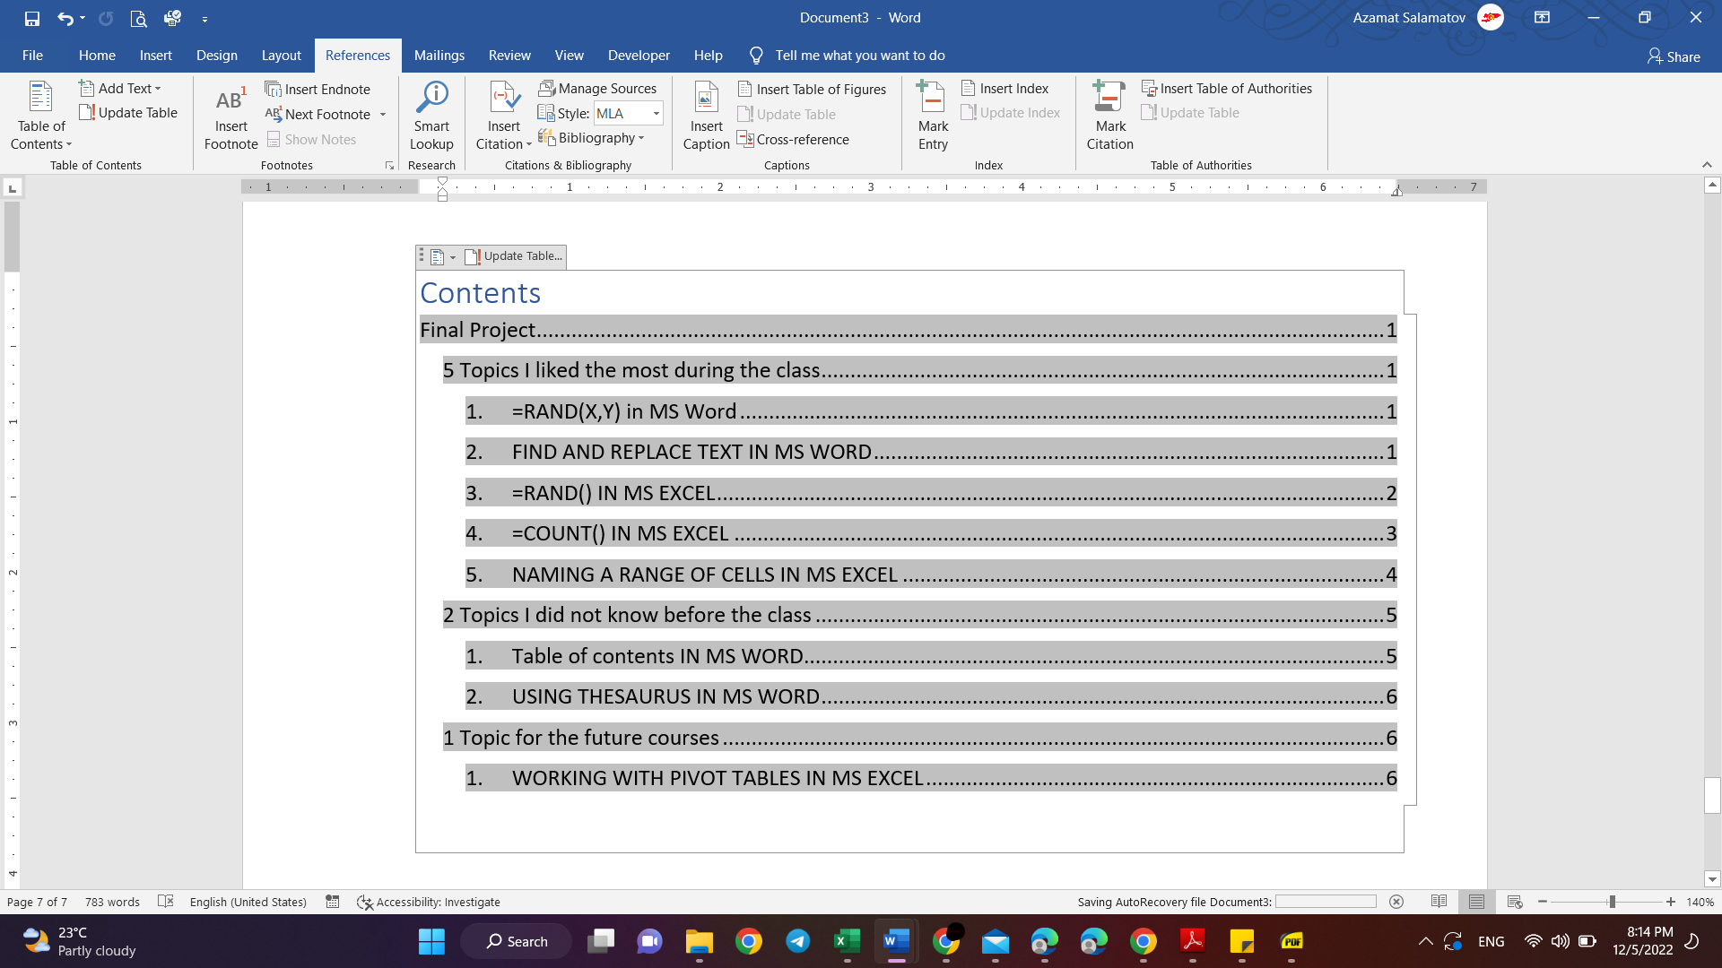

Figure

### USING THESAURUS IN MS WORD

In the review tab of the MS Word, on the left, we can find thesaurus. It is very useful when writing essays, to find synonyms, antonyms etc.

Ex:

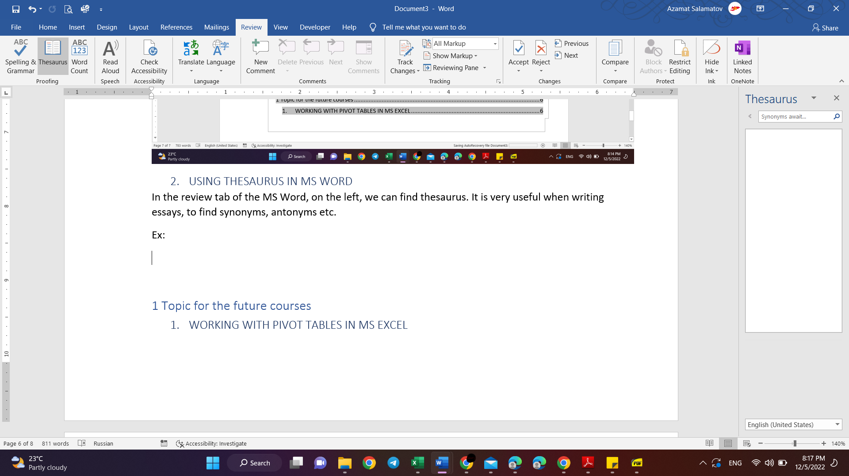

Figure

Then, we either write our word to the search bar:

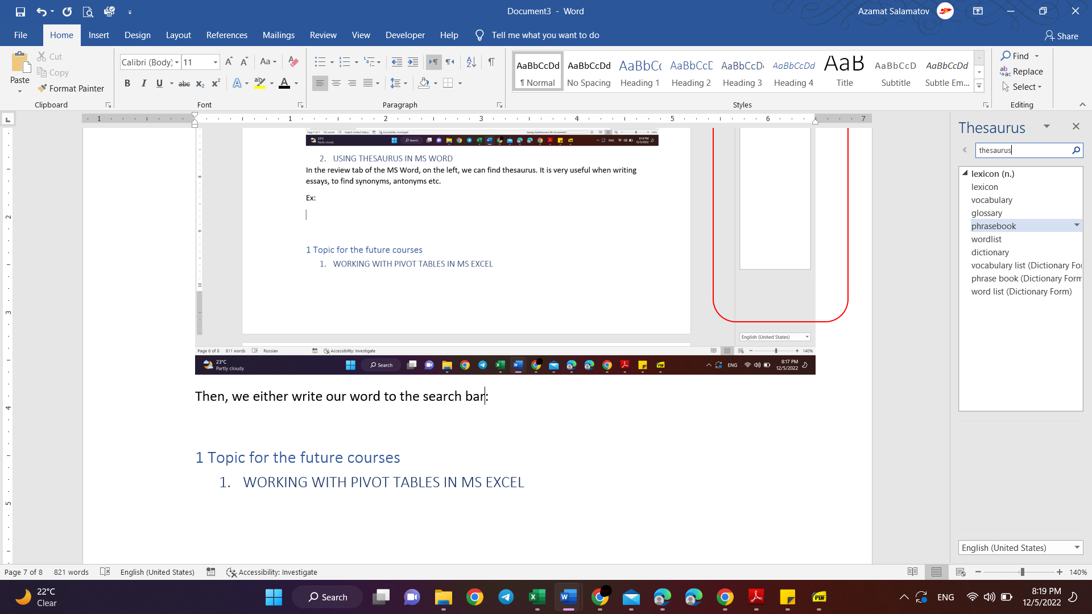

Figure

## 1 Topic for the future courses

### WORKING WITH PIVOT TABLES IN MS EXCEL

You can quickly summarize your data using pivot tables in excel.

Let us look at this example:

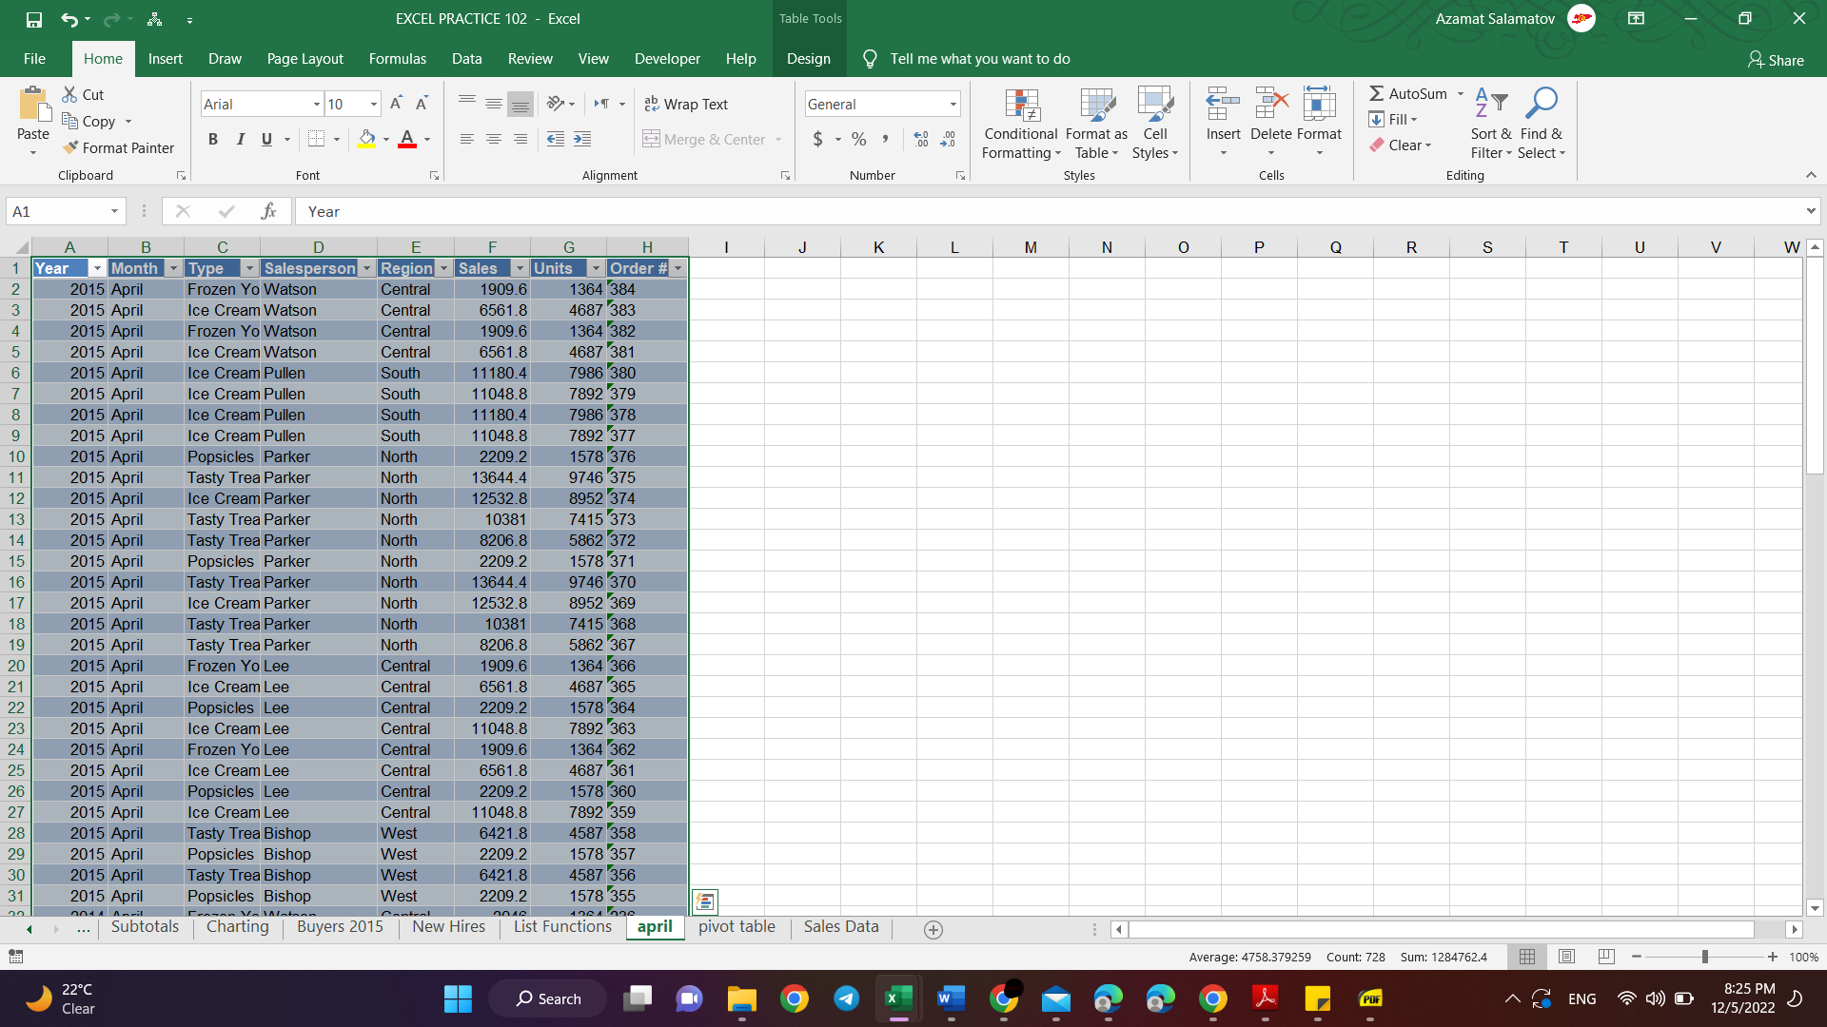

Figure

Then we go the insert tab:

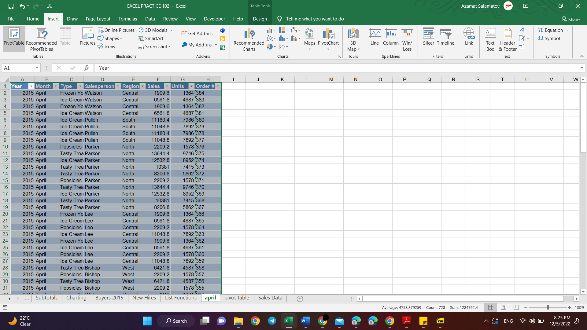

Figure

Then, a new worksheet opens:

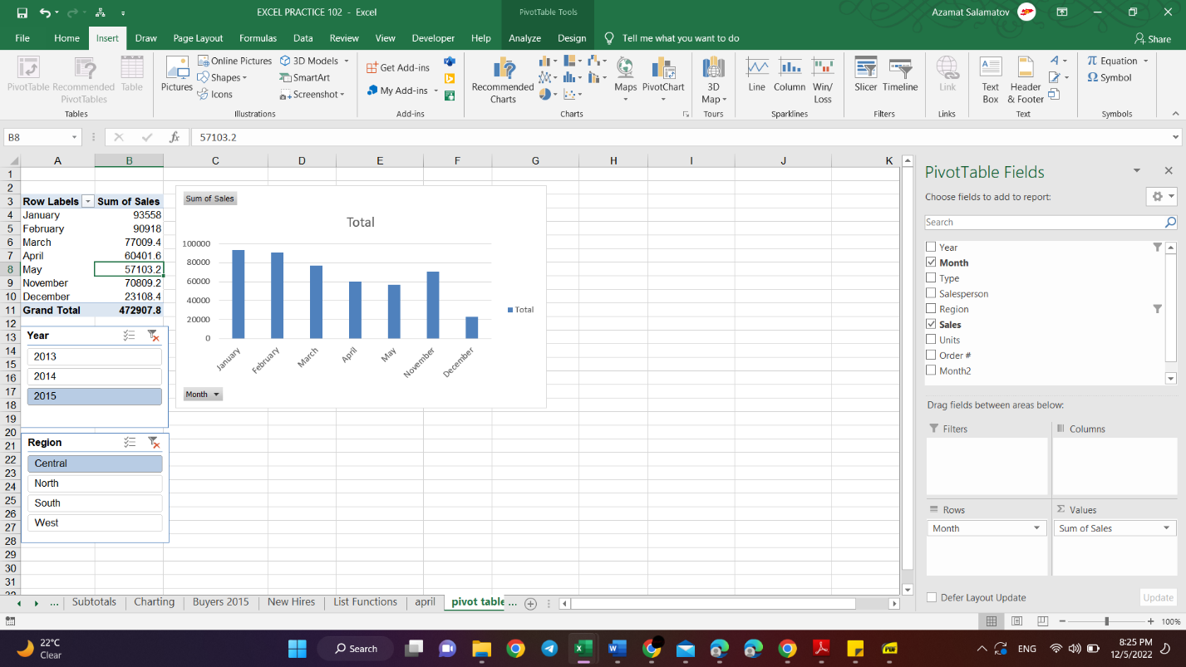

Figure

Here is the pivot table, then I added an additional chart to make a visual explanation.

# References

Microsoft. "Count function - Microsoft Support." n.d. *Count function - Microsoft Support.*

—. "Find Function - Microsoft Support." n.d.

—. "Naming a Range - Microsoft Support." n.d. *Naming a Range - Microsoft Support.*

—. "PMT function - Microsoft Support." n.d. *PMT function - Microsoft Support.*

## Table of figures

Figure 1 1

Figure 2 2

Figure 3 2

Figure 4 3

Figure 5 3

Figure 6 4

Figure 7 4

Figure 8 5

Figure 9 5

Figure 10 6

Figure 11 6

Figure 12 7

Figure 13 7

Figure 14 8

Figure 15 8

Figure 16 9

Contents

Final Project 1

5 Topics I liked the most during the class 1

1. =RAND(X,Y) in MS Word 1

2. FIND AND REPLACE TEXT IN MS WORD 1

3. =RAND() IN MS EXCEL 2

4. =COUNT() IN MS EXCEL 3

5. NAMING A RANGE OF CELLS IN MS EXCEL 5

2 Topics I did not know before the class 6

1. Table of contents IN MS WORD 6

2. USING THESAURUS IN MS WORD 7

1 Topic for the future courses 8

1. WORKING WITH PIVOT TABLES IN MS EXCEL 8

References 10

Table of figures 10